|  |
| --- |
| INFORMATION SYSTEMS PRACTICALS 2024 |
| HOSPITAL DATABASE SYSTEM |
| OCTOBER – NOVEMBER 2024 |

|  |
| --- |
| * MOKEKOLOANA MODIBA * LESEDI MOTAU * VUYELO HLUNGWANE * MOSIBUDI SEWAPE * LINDA SKHOSANE |

Table of Contents

*TOPIC & BRIEF BACKGROUND* 2

*BUSINESS RULES* 3

*ERD DATABASE DESIGN* 4

*DATA DICTIONARY* 5

REPORT 8

# *TOPIC & BRIEF BACKGROUND*

* **BACKROUND/HISTORY:** According to our research, Hospital Management System emerged in the 1960's with early systems focusing on basic administration tasks like patient registration and billing. -Back then they were using physical files to store patient information and payments. The old system was time consuming, and some files were easily lost or stolen, it made the process more difficult to work with. -Over the years HMS has evolved to incorporate new technologies and features such as electronic health records (EHRs), telemedicine and data analytics that made the workload easier and less time consuming. These new technologies are easy to use, and they protect private information.
* **DEFINITION**: A *hospital management system* is a detailed software solution designed to manage and simplify the administration, clinical and financial operations of a hospital or health care facility.
* **GOAL:** The goal is to create a robust, efficient, and secure database that supports the operational needs of the hospital while ensuring data integrity and facilitating easy access and reporting. We will design a schema with proper tables and relationships, normalizing the data, implementing security measures, optimizing for performance, and thoroughly testing the system. Once deployed, continuous maintenance ensures the database remains efficient and secure.

# *BUSINESS RULES*

* A medical aid can be had by one or many patients.
* A patient must consult with one or many doctors.
* A doctor may consult with many or no patients.
* Nurses may be assigned to one or many wards depending on their shifts.
* A ward may be assigned to one or many nurses.
* A ward may be assigned to one or many patients.
* A patient must receive one and only one prescription from a doctor.
* A doctor may give prescription to many no patients.
* A patient must make one payment.
* Payments can be made by one or many patients.

# *ERD DATABASE DESIGN*

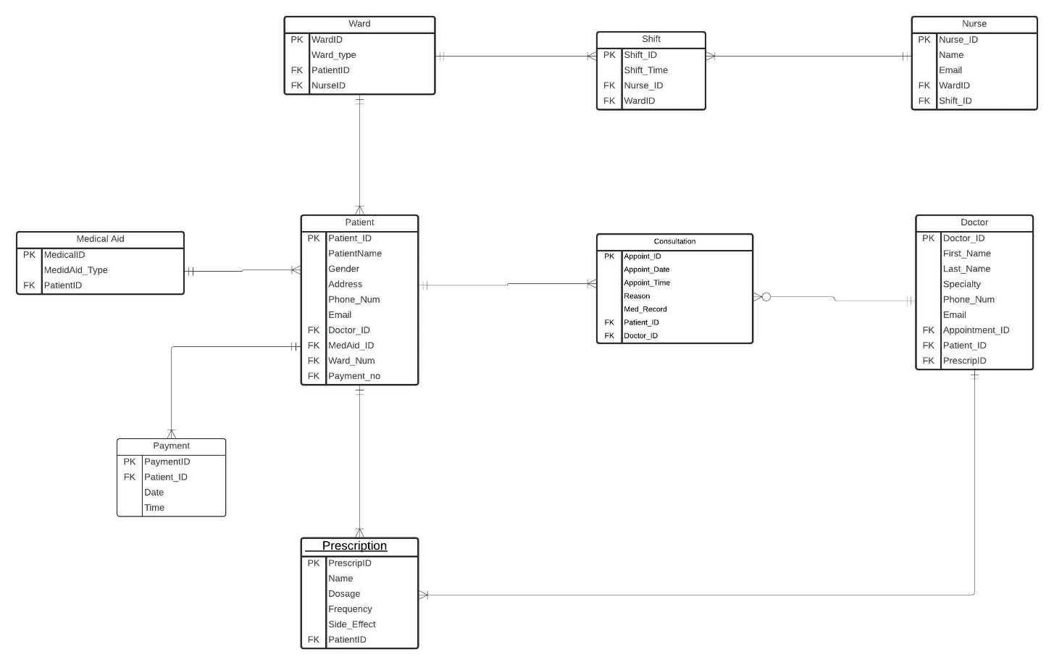

# *DATA DICTIONARY*

**PATIENT TABLE**

|  |  |  |
| --- | --- | --- |
| ATTRIBUTES | DATA TYPE | CONSTRAINTS |
| PatientID | VARCHAR2(13) | Primary key |
| PatientName | VARCHAR2(100) | Not Null |
| Gender | VARCHAR2(6) | Not Null |
| Address | VARCHAR2(150) | Not Null |
| Phone_Num | VARCHAR2(10) | Not Null |
| Email | VARCHAR2(80) | Not Null |
| DoctorID | VARCHAR2(13) | Foreign key |
| MedAidID | VARCHAR2(9) | Foreign key |
| Wardno | VARCHAR2(5) | Foreign key |
| PaymentID | VARCHAR2(10) | Foreign key |

**DOCTOR TABLE**

|  |  |  |
| --- | --- | --- |
| **ATTRIBUTES** | **DATA TYPE** | **CONSTRAINTS** |
| DoctorID | VARCHAR2(13) | Primary key |
| FirstName | VARCHAR2(50) | Not Null |
| LastName | VARCHAR2(50) | Not Null |
| Speciality | VARCHAR2(150) | Not Null |
| PhoneNum | VARCHAR2(10) | Not Null |
| Email | VARCHAR2(80) | Not Null |
| AppointmentID | VARCHAR2(13) | Foreign key |
| PatientID | VARCHAR2(13) | Foreign key |
| PrescripID | VARCHAR(15) | Foreign Key |

**CONSULTATION TABLE**

|  |  |  |
| --- | --- | --- |
| **ATTRIBUTE** | **DATA TYPE** | **CONSTRAINTS** |
| ConsultationID | VARCHAR2(13) | Primary Key |
| ConsultationDate | DATE | Not Null |
| Consultation_Time | DATE TIME | Not Null |
| Reason | VARCHAR2(100) | Not Null |
| Med Record | VARCHAR2(150) | Not Null |
| PatientID | VARCHAR2(13) | Foreign key |
| DoctorID | VARCHAR2(13) | Foreign key |

**PAYMENT TABLE**

|  |  |  |
| --- | --- | --- |
| **ATTRIBUTE** | **DATA TYPE** | **CONSTRAINTS** |
| PaymentID | VARCHAR2(10) | Primary |
| Date | DATE | Not Null |
| Time | DATE TIME | Not Null |
| PatientID | VARCHAR2(13) | Foreign key |

**NURSE TABLE**

|  |  |  |
| --- | --- | --- |
| **ATTRIBUTE** | **DATA TYPE** | **CONTRAINTS** |
| NurseID | VARCHAR2(13) | Primary key |
| Name | VARCHAR2(100) | Not Null |
| Email | VARCHAR2(80) | Not Null |
| WardID | VARCHAR2(5) | Foreign key |
| ShiftID | VARCHAR2(13) | Foreign key |

**SHIFT TABLE**

|  |  |  |
| --- | --- | --- |
| **ATTRIBUTE** | **DATA TYPE** | **CONTRAINTS** |
| ShiftID | VARCHAR2(13) | Primary key |
| Shift_Time | DATE TIME | Not Null |
| NurseID | VARCHAR2(13) | Foreign key |
| WardID | VARCHAR2(5) | Foreign key |

**WARD TABLE**

|  |  |  |
| --- | --- | --- |
| **ATTRIBUTE** | **DATA TYPE** | **CONSTRAINTS** |
| WardID | VARCHAR2(5) | Primary key |
| Ward_type | VARCHAR2(50) | Not Null |
| PatientID | VARCHAR2(13) | Foreign key |
| NurseID | VARCHAR2(13) | Foreign key |

**MEDICAL AID TABLE**

|  |  |  |
| --- | --- | --- |
| **ATTRIBUTE** | **DATA TYPE** | **CONTRAINTS** |
| MedicalID | VARCHAR2(15) | Primary key |
| MedicalAid_Type | VARCHAR2(150) | Not Null |
| Patient_ID | VARCHAR2(13) | Foreign key |

**PRESCRIPTION TABLE**

|  |  |  |
| --- | --- | --- |
| **ATTRIBUTE** | **DATA TYPE** | **CONTRAINTS** |
| PrescripID | VARCHAR2(13) | Primary key |
| Name | VARCHAR2(100) | Not Null |
| Dosage | VARCHAR2(100) | Not Null |
| Frequency | VARCHAR2(150) | Not Null |
| Side_Effect | VARCHAR2(300) | Not Null |
| PatientID | VARCHAR2(13) | Foreign key |

# REPORT

* Prescription report ---This report will display the Patient_ID, dosage, side effects, and frequency at which the medicine is to be taken.
* Schedule shifts report---This report displays the time at which a nurse has to be attending to patients.
* Payment report---This report will display the date and time of payment as well as the amount paid.
* Consultation Report---This report display the time and date at which a specific doctor and patient meet.